Design Choices
- Framework Selection
  - Backend: Used Flask for simplicity and rapid API development.
  - Front-end: HTML-based chat interface (index.html) for lightweight deployment.
- Session Management
  - Implemented Neo4j graph database for storing sessions and messages.
  - Each session is represented as a node, and messages are linked via HAS_MESSAGE relationships for easy retrieval and context tracking.
- Dialogue Management
  - EnhancedIntentClassifier: Keyword-based intent detection with confidence scoring.
  - EnhancedResponseGenerator: Context-aware responses using:
    - Follow-up detection
    - Topic shift handling
    - Entity substitution for personalization.
- Context Retention
  - Maintains a context window of recent messages (default: 6) for multi-turn dialogue.
  - Uses Neo4j queries to fetch historical messages efficiently.
- Caching & Performance
  - Applied LRU caching for repeated computations (e.g., intent classification).
  - Rate limiting via Flask-Limiter to prevent abuse.
- Security & Validation
  - Input validation and sanitization to prevent XSS or malformed requests.
  - Environment variables for sensitive credentials (Neo4j URI, user, password).
- API Design
  - REST endpoints for:
    - Session creation (/api/session/create)
    - Message handling (/api/message/send)
    - Conversation history & export
    - Feedback submission
    - Analytics summary
  - Integrated Swagger for API documentation.
- Neo4j Graph Database
- Why Neo4j?
- Graph structure is ideal for representing sessions, messages, and their relationships.
- Enables efficient queries for context retrieval and analytics.
  - Schema Design
    - Nodes:
      - Session: Attributes → session_id, user_id, created_at, last_interaction, interaction_count, user_intent, topics_discussed.
      - Message: Attributes → message_id, sender, text, intent, entities, confidence, timestamp.
    - Relationships:
      - (:Session)-[:HAS_MESSAGE]->(:Message) for conversation history.
  - Constraints
    - Unique constraints on session_id and message_id for data integrity.
  - Analytics
    - Aggregate queries for:
      - Total sessions
      - Average messages per session
      - Intent distribution
      - Feedback counts

- Caching & Performance
- LRU Cache for repeated computations (intent classification).
- Neo4j connection pooling for high concurrency.
- Rate limiting: 30 requests/minute per user.

- Future Improvements
- Integrate LLMs (GPT or HuggingFace) for richer responses.
- Add embedding-based intent detection for better accuracy.
- Implement query-level caching for faster context retrieval.
- Support federated Neo4j clusters for high availability.

✅ Challenges Faced
- Neo4j Integration
  - Ensuring proper constraint creation and handling connection pool limits.
  - Managing transaction consistency for session and message nodes.
- Context Handling
  - Designing logic for follow-up detection and topic shift without heavy ML models.
  - Balancing accuracy vs. performance for keyword-based intent classification.
- Response Generation
  - Creating dynamic templates for different intents while supporting entity substitution.
  - Avoiding repetitive responses in multi-turn conversations.
- Scalability
  - Managing large conversation histories without performance degradation.
  - Deciding between in-memory vs. persistent storage for context.
- Error Handling
  - Graceful fallback for missing sessions or invalid inputs.
  - Handling unexpected Neo4j query failures.

✅ Interpretation
The design prioritizes context-aware dialogue, graph-based session management, and lightweight intent classification for customer support use cases. While the system is robust for small to medium-scale deployments, future improvements could include:
- ML-based intent detection for better accuracy.
- Caching at DB query level for faster context retrieval.
- Integration with LLMs for richer responses.

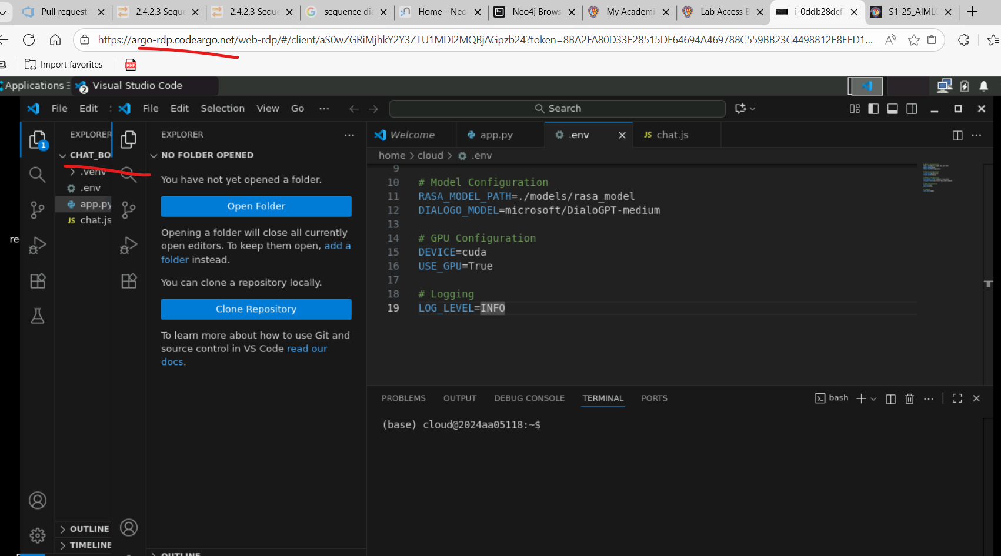

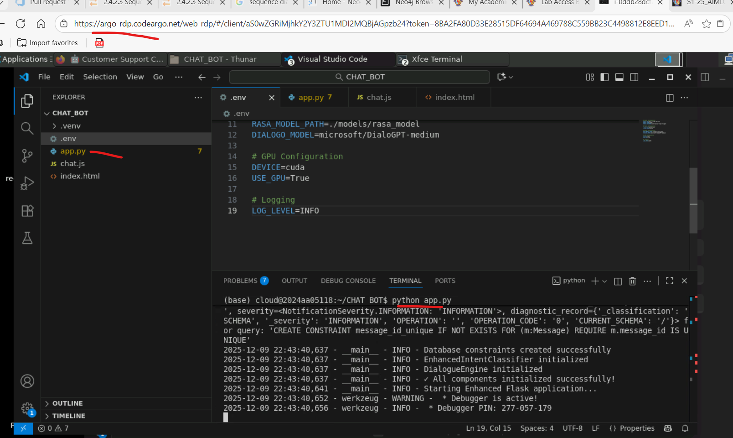

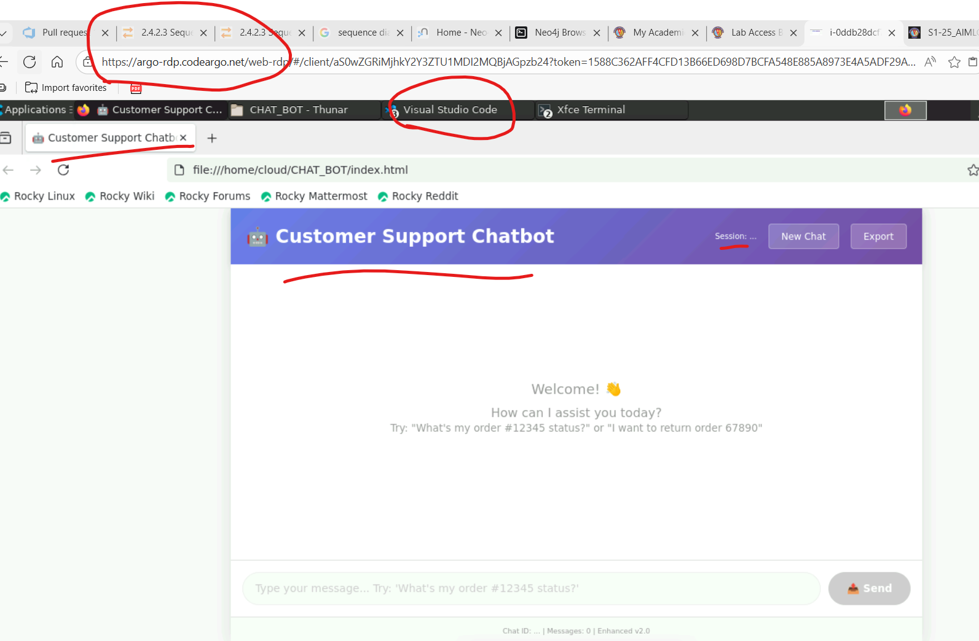

Neo4j Integration:
